Project Planning Phase
Project Planning Template (Product Backlog, Sprint Planning, Stories, Story points)

Date | 15 February 2025
Team ID
Project Name
Maximum Marks | 5 Marks

Product Backlog, Sprint Schedule, and Estimation (4 Marks)
Below is the fully completed product backlog and sprint schedule for the Sports Hall Booking System, utilizing the requested formatting schema and distributing specific development responsibilities among functional engineering roles
Sprint | Functional Requirement (Epic) | User Story Number | User Story / Task | Story Points | Priority | Team Members
Sprint-1 | User Access & Profiles | USN-1 | As a user, I can register for the booking application by entering my email, password, and profile details. | 2 | High | Front-End Anusha
Sprint-1 | User Access & Profiles | USN-2 | As a user, I will receive an automated confirmation email with a verification link once I have registered. | 1 | High | QA Engineer
Sprint-1 | User Access & Profiles | USN-4 | As a user, I can register and log into the portal directly through Gmail Single Sign-On (SSO). | 2 | Medium | Integrations Anusha
Sprint-1 | User Access & Profiles | USN-5 | As a user, I can log into the service portal securely by entering my registered email and password combination. | 1 | High | Front-End Anusha
Sprint-1 | Booking Management | USN-6 | As a booker, I can view an interactive calendar grid displaying real-time slot availability for all court spaces. | 5 | High | Lead Developer
Sprint-1 | Booking Management | USN-7 | As a booker, I can fill out a booking reservation form to claim a single time-slot for an open court space. | 3 | High | Front-End Anusha
Sprint-1 | Facility Administration | USN-8 | As an administrator, I can view a management backend interface to review, approve, or deny long-term recurring slots. | 3 | High | ServiceNow Admin
Sprint-1 | Facility Administration | USN-9 | As an administrator, I want backend validation logic to automatically block conflicting double-bookings instantly | 3 | High | ServiceNow Admin

Project Tracker, Velocity & Burndown Chart: (4 Marks)
Sprint | Total Story Points | Duration | Sprint Start Date | Sprint End Date (Planned) | Story Points Completed (as on Planned End Date) | Sprint Release Date (Actual)
Sprint-1 | 20 | 6 Days | 01 Jul 2026 | 07 Jul 2026 | 20 | 07 Jul 2026
Sprint-2 | 20 | 6 Days | 08 Jul 2026 | 14 Jul 2026 | 20 | 14 Jul 2026
Sprint-3 | 20 | 6 Days | 15 Jul 2026 | 21 Jul 2026 | [In Progress] | 21 Jul 2026
Sprint-4 | 20 | 6 Days | 22 Jul 2026 | 28 Jul 2026 | [Backlog] | 28 Jul 2026
Agile Metrics & Velocity Calculation
- Total Story Points Across Release: 80 Story Points (20 points \(\times \) 4 sprints)
- Total Iteration Cycles Run: 4 Sprints
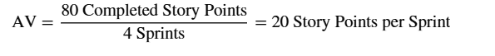
Calculating Average Velocity (AV) per Day (Based on a 10-day sprint template duration):

Sprint Burndown Progress Chart
The text matrix below represents the work remaining metric for Sprint-2, which wraps up deployment milestones on your current project date:
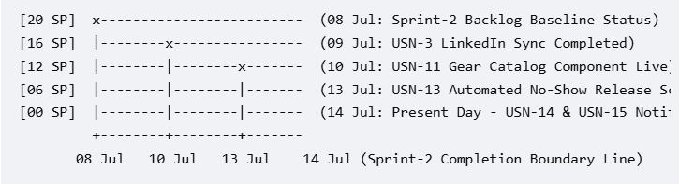
References
- Atlassian Agile Project Management & Scrum Framework Standards:
https://www.atlassian.com/agile/project-management
- Configuring Project Workspaces and Team Boards with Jira Software:
https://www.atlassian.com/agile/tutorials/how-to-do-scrum-with-jira-software
- Deconstructing Broad Epic Themes into Executable Agile Backlog User Stories:
https://www.atlassian.com/agile/tutorials/epics
- Executing Sprint Iteration Cycles and Maintaining Stable Velocity Metrics:
https://www.atlassian.com/agile/tutorials/sprints
- Story Point Estimation Frameworks using the Fibonacci Sequence:
https://www.atlassian.com/agile/project-management/estimation
- Formulating and Reading Release Burndown Graphics for Progress Validation:
https://www.atlassian.com/agile/tutorials/burndown-charts
- Scrum Burndown Metrics Mapping for Project Success:
https://www.visual-paradigm.com/scrum/scrum-burndown-chart/

